API Migration

🌟 Definition
# Source: AI Source: Provided by: [Data Path: Persons Table -> ID Column: 1, Name_En Column: Motasem Essam] -> From: [ChatGPT] on [6/7/2026]
API Migration is the process of moving an application, system, or integration from one API version, API provider, or API architecture to another.
The goal is to maintain or improve functionality while adapting to changes in the API.

🎯 Purpose
# Source: AI Source: Provided by: [Data Path: Persons Table -> ID Column: 1, Name_En Column: Motasem Essam] -> From: [ChatGPT] on [6/7/2026]
API migration is performed to:
- Upgrade to newer API versions
- Replace deprecated APIs
- Improve security
- Access new features
- Improve performance
- Switch service providers
- Modernize system integrations

🧠 Simple Definition
# Source: AI Source: Provided by: [Data Path: Persons Table -> ID Column: 1, Name_En Column: Motasem Essam] -> From: [ChatGPT] on [6/7/2026]
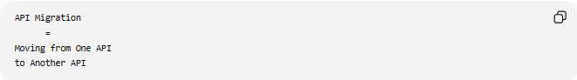
API Migration
=
Moving from One API
to Another API

📚 What Can Be Migrated?
# Source: AI Source: Provided by: [Data Path: Persons Table -> ID Column: 1, Name_En Column: Motasem Essam] -> From: [ChatGPT] on [6/7/2026]
API migrations may involve:
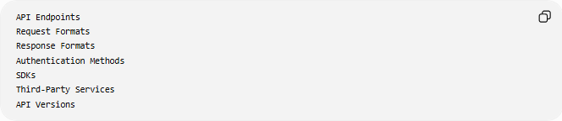
API Endpoints
Request Formats
Response Formats
Authentication Methods
SDKs
Third-Party Services
API Versions

🔍 Common Types of API Migration

1️⃣ API Version Migration
# Source: AI Source: Provided by: [Data Path: Persons Table -> ID Column: 1, Name_En Column: Motasem Essam] -> From: [ChatGPT] on [6/7/2026]
Move from an old API version to a newer one.
Example
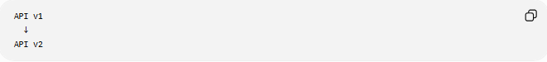
API v1
↓
API v2

Before
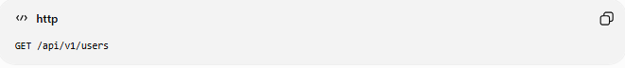
GET /api/v1/users

After
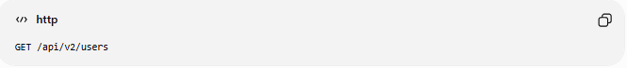
GET /api/v2/users

Benefits:
- New features
- Bug fixes
- Better security

2️⃣ API Provider Migration
# Source: AI Source: Provided by: [Data Path: Persons Table -> ID Column: 1, Name_En Column: Motasem Essam] -> From: [ChatGPT] on [6/7/2026]
Switch from one provider to another.
Example
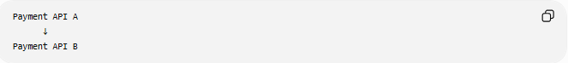
Payment API A
↓
Payment API B
Examples:
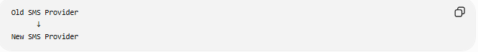
Old SMS Provider
↓
New SMS Provider
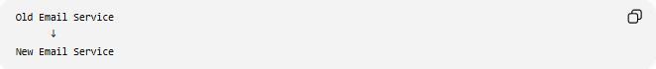
Old Email Service
↓
New Email Service

3️⃣ Authentication Migration
# Source: AI Source: Provided by: [Data Path: Persons Table -> ID Column: 1, Name_En Column: Motasem Essam] -> From: [ChatGPT] on [6/7/2026]
Change API authentication methods.
Example
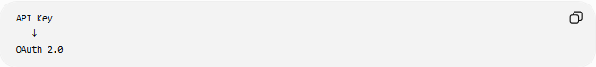
API Key
↓
OAuth 2.0

Before
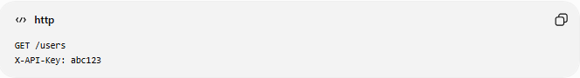
GET /users
X-API-Key: abc123

After
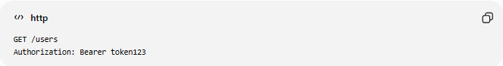
GET /users
Authorization: Bearer token123

Benefits:
- Better security
- User authorization support

4️⃣ Architecture Migration
# Source: AI Source: Provided by: [Data Path: Persons Table -> ID Column: 1, Name_En Column: Motasem Essam] -> From: [ChatGPT] on [6/7/2026]
Move between API architectures.
Example
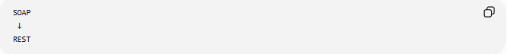
SOAP
↓
REST
Or
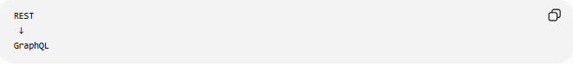
REST
↓
GraphQL

Benefits:
- Better flexibility
- Reduced bandwidth usage
- Easier development

5️⃣ Internal API Migration
# Source: AI Source: Provided by: [Data Path: Persons Table -> ID Column: 1, Name_En Column: Motasem Essam] -> From: [ChatGPT] on [6/7/2026]
Move internal services to new APIs.
Example
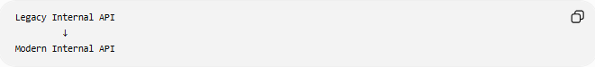
Legacy Internal API
↓
Modern Internal API
Common during:
Microservices Adoption
System Modernization

🛠️ Real-World Example
# Source: AI Source: Provided by: [Data Path: Persons Table -> ID Column: 1, Name_En Column: Motasem Essam] -> From: [ChatGPT] on [6/7/2026]
Before Migration
Weather API Version 1:
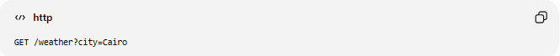
GET /weather?city=Cairo

Response:
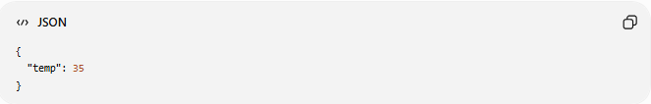
{
"temp": 35
}

After Migration
Weather API Version 2:
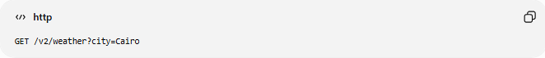
GET /v2/weather?city=Cairo

Response:
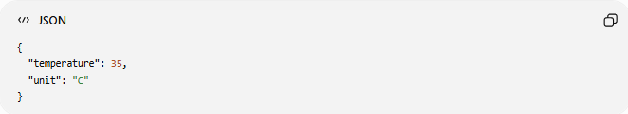
{
"temperature": 35,
"unit": "C"
}

Application code must be updated to handle the new response structure.

🔄 API Migration Lifecycle
# Source: AI Source: Provided by: [Data Path: Persons Table -> ID Column: 1, Name_En Column: Motasem Essam] -> From: [ChatGPT] on [6/7/2026]
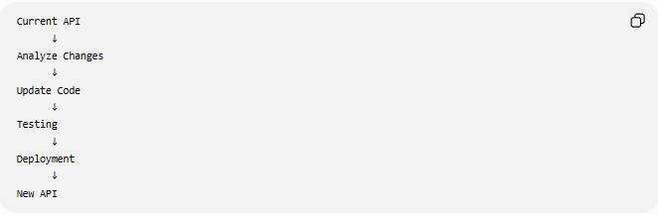
Current API
↓
Analyze Changes
↓
Update Code
↓
Testing
↓
Deployment
↓
New API

📦 Common Migration Tasks
# Source: AI Source: Provided by: [Data Path: Persons Table -> ID Column: 1, Name_En Column: Motasem Essam] -> From: [ChatGPT] on [6/7/2026]
Update Endpoint URLs
Before
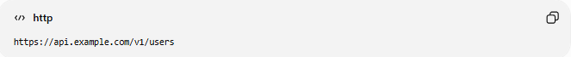
https://api.example.com/v1/users

After
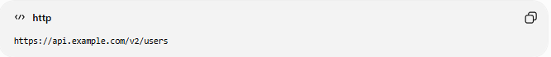
https://api.example.com/v2/users

Update Request Parameters
Before
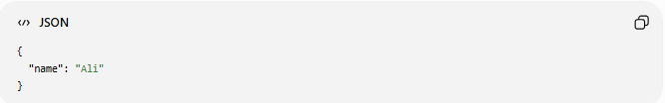
{
"name": "Ali"
}

After
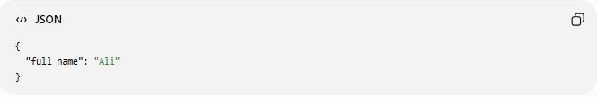
{
"full_name": "Ali"
}

Update Response Handling
Before
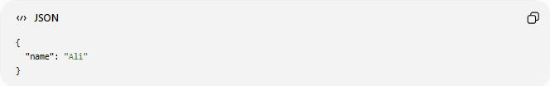
{
"name": "Ali"
}

After
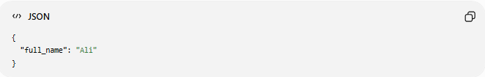
{
"full_name": "Ali"
}

🌍 Example: Payment API Migration
# Source: AI Source: Provided by: [Data Path: Persons Table -> ID Column: 1, Name_En Column: Motasem Essam] -> From: [ChatGPT] on [6/7/2026]
Before
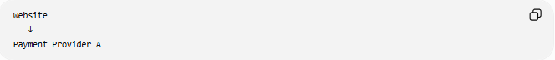
Website
↓
Payment Provider A

After
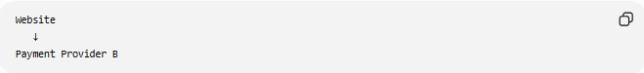
Website
↓
Payment Provider B
Migration tasks:
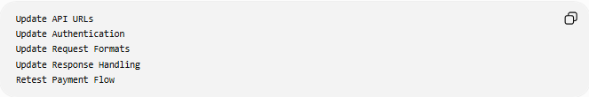
Update API URLs
Update Authentication
Update Request Formats
Update Response Handling
Retest Payment Flow

⚠️ Challenges of API Migration
# Source: AI Source: Provided by: [Data Path: Persons Table -> ID Column: 1, Name_En Column: Motasem Essam] -> From: [ChatGPT] on [6/7/2026]
Possible issues:
- Breaking changes
- Authentication failures
- Data format changes
- Rate limit differences
- Deprecated endpoints
- Integration failures

✅ Best Practices
# Source: AI Source: Provided by: [Data Path: Persons Table -> ID Column: 1, Name_En Column: Motasem Essam] -> From: [ChatGPT] on [6/7/2026]
Read API Documentation
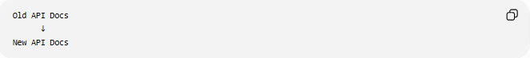
Old API Docs
↓
New API Docs

Test Thoroughly
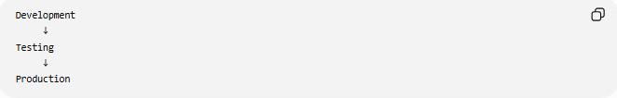
Development
↓
Testing
↓
Production

Support Both Versions Temporarily
API v1
API v2
Run both during transition if possible.

Monitor After Deployment
Check:
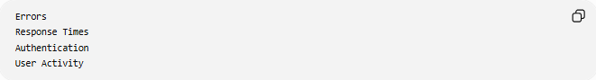
Errors
Response Times
Authentication
User Activity

📊 API Migration vs Application Migration
# Source: AI Source: Provided by: [Data Path: Persons Table -> ID Column: 1, Name_En Column: Motasem Essam] -> From: [ChatGPT] on [6/7/2026]
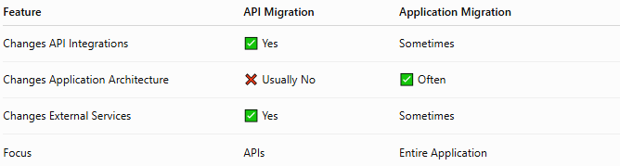
Feature | API Migration | Application Migration
Changes API Integrations | ✅ Yes | Sometimes
Changes Application Architecture | ❌ Usually No | ✅ Often
Changes External Services | ✅ Yes | Sometimes
Focus | APIs | Entire Application

🛠️ Common API Tools
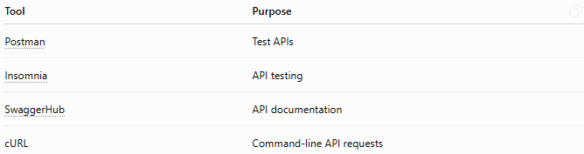
Tool | Purpose
Postman | Test APIs
Insomnia | API testing
SwaggerHub | API documentation
cURL | Command-line API requests

🧠 Simple Analogy
# Source: AI Source: Provided by: [Data Path: Persons Table -> ID Column: 1, Name_En Column: Motasem Essam] -> From: [ChatGPT] on [6/7/2026]
Imagine a delivery company changes its address format.
Old Format
Street Name
House Number

New Format
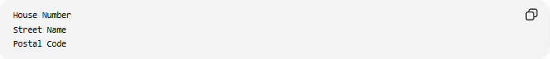
House Number
Street Name
Postal Code
Everyone sending packages must update their forms.
API migration works similarly:
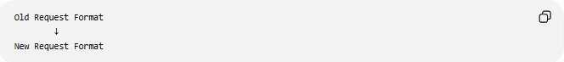
Old Request Format
↓
New Request Format
Applications must adapt to continue communicating correctly.

🧭 Summary
# Source: AI Source: Provided by: [Data Path: Persons Table -> ID Column: 1, Name_En Column: Motasem Essam] -> From: [ChatGPT] on [6/7/2026]
API Migration is the process of moving from one API version, provider, authentication method, or architecture to another. Common types include API version migration, provider migration, authentication migration, architecture migration (SOAP ↔ REST ↔ GraphQL), and internal API migration. API migrations help applications access new features, improve security, replace deprecated services, and modernize integrations while maintaining reliable communication between systems.

